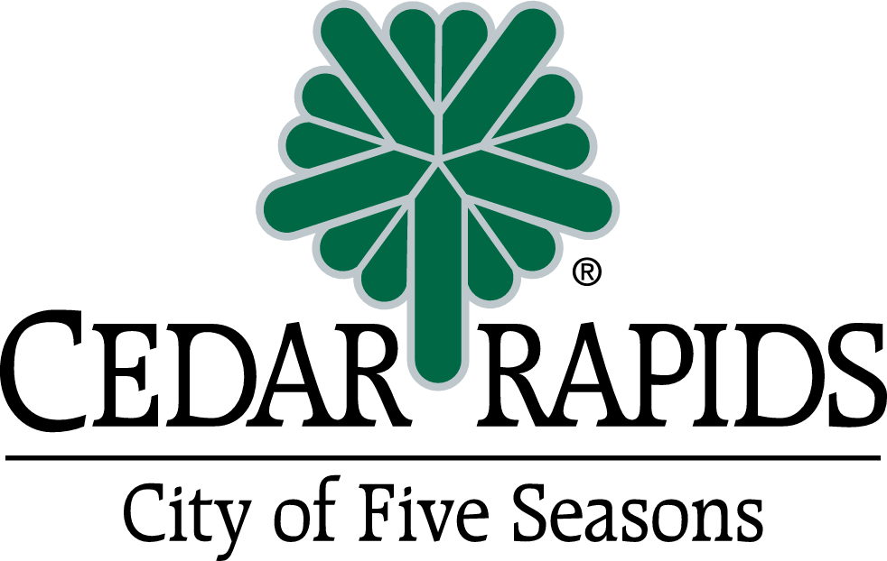[DATE]

**Notice of Property Assessment**

Dear Property Owner:

The City recently completed work on [PROJECT NAME] adjacent to your property. A portion of the costs are being assessed to property owners who directly benefit from the project. Cost estimates for these assessments were previously sent to property owners. Enclosed is the notice that was published in the Cedar Rapids Gazette on [DATE] and [DATE].

Please find attached a Final Assessment Notice listing the dollar amount that has been levied against your property for [TYPE OF IMPROVEMENT]. You are required to pay this final amount, which has been formally adopted per Iowa Code and cannot be waived or changed. Information on what to do next is listed below:

**IF MAKING PAYMENT *ON OR BEFORE* [DATE OF PUBLICATION + 30 DAYS]:**

You will not be charged interest on payment made before [DATE OF PUBLICATION + 30 DAYS]. You may pay all or any amount within this first thirty (30) days from [DATE OF 1ST PUBLICATION] interest-free. Payments will not be accepted if postmarked after [DATE OF PUBLICATION + 30 DAYS].

You will be responsible for paying online, mailing or hand-delivering a check (made out to “City Treasurer”) to the drop box outside City Hall within this 30-day timeframe to take advantage of this interest-free payment period:

**City Treasurer**

**Online:** cedar-rapids.org/pay_bill_online/ (“Make General Billing Payment”)

**Hand Deliver**: **Drop box** located at corner of First Street & 2nd Avenue SE outside City Hall

**Mail to:** PO Box 2148

Cedar Rapids, IA 52406-2148

*Please enclose your Final Assessment Notice with your check.*

*Please note your Customer Number and Invoice Number on your payment, which can be found on*

*the attached Final Assessment Notice.*

**IF MAKING PAYMENT *AFTER* [DATE OF PUBLICATION + 30 DAYS]**:

Any remaining unpaid assessment costs after [DATE OF PUBLICATION + 30 DAYS] will be certified to the Linn County Treasurer as a lien against the property in accordance with State Law. The Linn County Treasurer will send you a statement in August of each year, starting this year. The first annual payment will be due September 1, this year. This process will begin if you have unpaid assessments after [DATE OF PUBLICATION + 30 DAYS].

Unpaid balances will bear XX% interest from the date of the final assessment through December 1, [CURRENT YEAR] and each December 1st thereafter. Interest on the unpaid balance is according to Iowa Code Section 384.65 and cannot be waived. The balance, if over $500, will be spread over  annual payments, and will be included in your property tax bill.

Should you have any questions, please contact [CONTACT NAME] in Public Works at 319-286-5802, or [Consultant Contact] at Consultant Company] at [phone number] if you have general questions.

     /

cc: City Clerk

Brenna Fall, P.E., City Engineer

Andy Hoenig, Project Accountant

Chad Mittan, Accounts Receivable Program Manager

[Project Name]

Cedar Rapids, Iowa

CIP No.

**FREQUENTLY ASKED QUESTIONS · FINAL ASSESSMENTS**

**Q. Why did this project include assessing property owners?**

A. The majority of these improvements benefit the general public, and as such, approximately XX% of the cost are covered by general funds – contributed by all taxpayers. However, there is also some benefit that applies only to adjoining properties.  These assessments cover those direct property owner benefits, and make up approximately XX% of the project cost.

**Q: I / we didn’t live here when the previous notification went out. Is the previous owner responsible for some of the cost?**

A: The assessment is levied against the property, not the individual; which means the *current* property owner is responsible for the assessment.

**Q. How are the effective dates and interest rates determined?**

A. These are determined according to Iowa Code Section 384.65.

**Q: How are final assessments calculated?**

A: Under current policy, property owners are subject to a portion of actual project costs after final completion including construction, engineering, and administrative costs.

**Q: How do I pay the final assessment?**

A: You have 30 days from the date specified in your final assessment notice to pay the assessment in full to the City of Cedar Rapids Treasurer. Assessments paid outside of this 30-day window can be paid as a lump sum or over annual installments with your property tax bill through the Linn County Treasurer. See your Final Assessment Notice for more details.

**Q. If I don’t pay off my assessment in the first 30 days, can I still pay in one lump sum?**

A. Yes. Please contact the Linn County Treasurer to pay off the assessment in full. Interest rates may still apply.

**Q: Is there any help for people who can’t afford to pay the assessment?**

A: If the property owner is age 65 or older, or 18 or older and permanently disabled, the State of Iowa provides assistance for special assessments.  Forms and more details are available at the Linn County Treasurer, or online at <https://tax.iowa.gov/tax-credits-and-exemptions>. Look for the “Iowa Property Tax Credit for Senior and Disabled Citizens” form.

**Q. Who can I contact regarding the final assessment?**

A: If you have general questions about payment, you can contact [CONTACT NAME] in Public Works at [phone number] or [email address] However, the final assessment has been formally adopted per Iowa Code and the contact person cannot waive or change the final assessment.

*We appreciate the opportunity to address your questions*.

**Final Assessment Notice**

**City of Cedar Rapids**

[project name]

|  |  |  |  |  |
| --- | --- | --- | --- | --- |
| Customer No. | Invoice No. | Parcel No. & Legal Description | Property Owner and Mailing Address | **Final Assessment Amount** |
|  |  |  |  | **$XXX** |
|  |  | **TOTAL:** | | **$XXXX** |

**Description of Table**

The table above outlines the assessment(s) to your property that have been included as part of a capital improvement project. These assessments are going toward a portion of the final project cost associated with [insert type of improvement].

**IF MAKING PAYMENT *ON OR BEFORE* [DATE OF PUBLICATION + 30 DAYS]:**

You will not be charged interest on payment(s) made before [DATE OF PUBLICATION + 30 DAYS]. Payments will not be accepted if postmarked after [DATE OF PUBLICATION + 30 DAYS].

You will be responsible for paying online, mailing or hand-delivering a check (made out to “City Treasurer”) to the drop box outside City Hall within this 30-day timeframe to take advantage of this interest-free payment period:

**City Treasurer**

**Online:** cedar-rapids.org/pay_bill_online/ (“Make General Billing Payment”)

**Hand Deliver**: **Drop box** located at corner of First Street & 2nd Avenue SE outside City Hall

**Mail to:** PO Box 2148

Cedar Rapids, IA 52406-2148

*Please enclose your Final Assessment Notice with your check.*

*Please note your Customer Number and Invoice Number on your payment, which can be found on the attached Final Assessment Notice.*

**IF MAKING PAYMENT *AFTER* [DATE OF PUBLICATION + 30 DAYS]**:

Any remaining unpaid assessment costs after [DATE OF PUBLICATION + 30 DAYS] will be certified to the Linn County Treasurer as a lien against the property in accordance with State Law. The Linn County Treasurer will send you a statement in August of each year, starting this year. The first annual payment will be due September 1, this year. This process will begin if you have unpaid assessments after [DATE OF PUBLICATION + 30 DAYS].

Unpaid balances will bear XX% interest from the date of the final assessment through December 1, [CURRENT YEAR] and each December 1st thereafter. Interest on the unpaid balance is according to Iowa Code Section 384.65 and cannot be waived. The balance, if over $500, will be spread over annual payments, and will be included in your property tax bill.

If you choose to pay over 10 years, and you are currently paying your mortgage through your lender, please inform them of the assessments to ensure smooth payments.