Supplier Registration Quick Tutorial

Welcome to Supplier Registration
This document provides instructions on how to register with the City of Cedar Rapids e-procurement system, Ion Wave Technologies (IWT) software. Please take note of the following.
- Completing registration does not mean that you have been or will be awarded business with this organization.
- Any changes or modifications to this supplier profile will need to be completed by the supplier. It is not the City’s responsibility to manage this information.

Registration Process:
To begin the registration process, log in to https://citycrbids.ionwave.net and select the “Supplier Registration” link on the organization’s page. You will be prompted to enter your Company Name, Telephone Number, and DUNS (if applicable). If you are providing an international telephone, check the box next to “International” and enter information accordingly. Select ‘Next’ to proceed. (See Figure 1.)
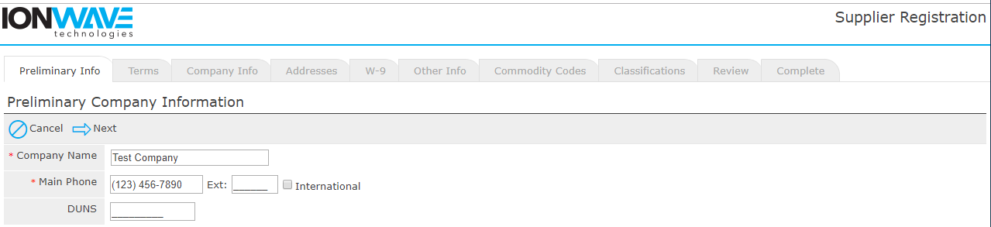
Figure 1

The system will search this City’s supplier database for an exisiting supplier account. If a duplication or similar supplier account is found, we suggest contacting the primary user of the registered account to be added as an additional user on the account. If this is not your company, you can proceeed by clicking ‘Create New Supplier’. (See Figure 2.)

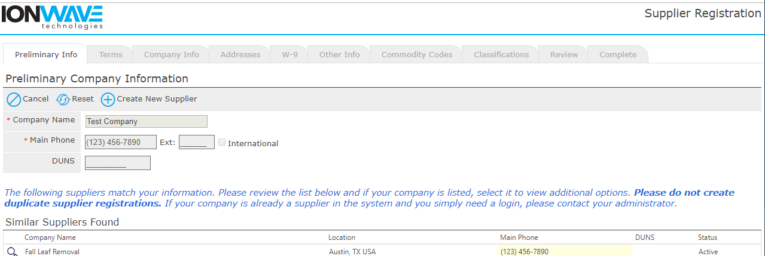
Figure 2
Terms and Conditions:
On this screen, you are required to agree with the Terms and Conditions of using the system. If necessary, you can click the ‘Printer-Friendly Version’ link to print the terms for offline review. Once you have reviewed the terms and are in agreement, check the box and click ‘Next’. (See Figure 3.)

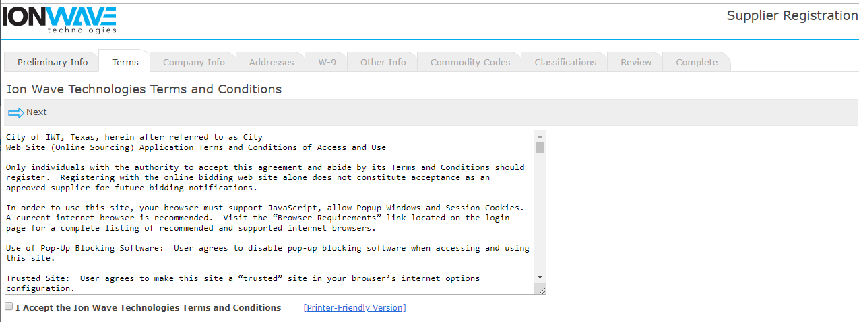
Figure 3

Company Information:
The system requires certain information before being able to proceed. These areas are indicated with a red asterisk *. (See Figure 4.)

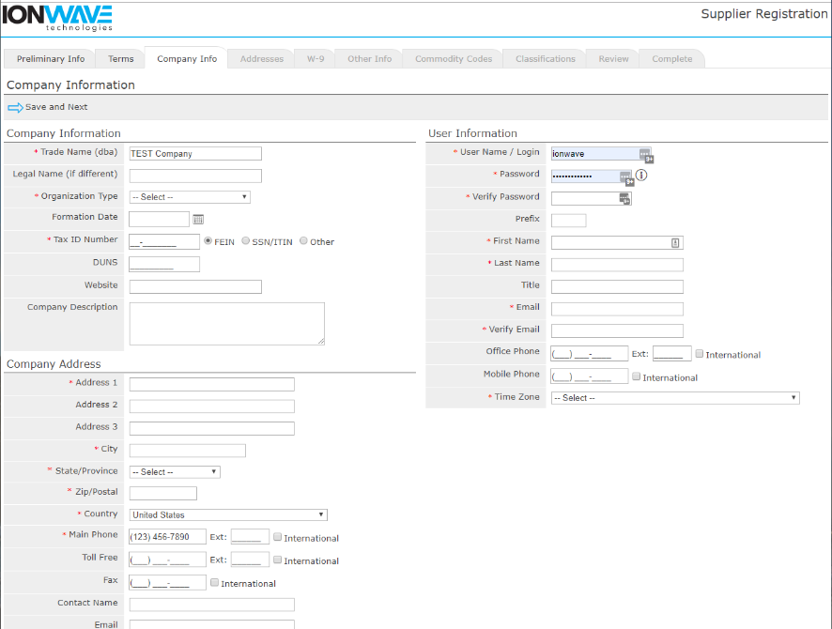
Figure 4

- Trade Name/Legal Name – If your company has separate operating names, please provide both in the designated area. If your company has the same Trade and Legal name, only enter this information in the Trade Name area.
- Organization Type – Select appropriate type from the drop-down menu
  - (International) – If your organization is outside of the United States, please select Foreign Entity from the Organization drop-down selection.
- Tax ID Number –
  - (International) – if your organization is outside the United States, please select OTHER
- Company Address - By default, the system will utilize this as your primary communication. Additional addresses can be added in the next step.
- Time Zone -
Important Note: Selecting your correct Time Zone (including the observation of Daylight Savings) will ensure that the time of Issue Dates, Closed Dates, and Activity Dates are displayed accurately. (See Figure 5.)
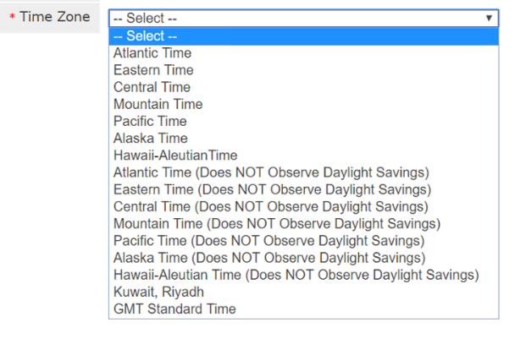
Figure 5

Select “Save and Next” on the top left-hand side to proceed. (See Figure 4 above.)

Verify Email Address – The system will send an email link that will verify your email address is valid and working. Once received, you must click on the provided link in the email to continue the registration.

The “From” address is provided in the pop-up box. We suggest adding this email address to your Safe Senders list (whitelist).

NOTE: If you do not receive the verification email, check your Junk/Clutter folders or contact your IT staff to ensure this email has not been blocked by your company’s network.

The link provided in the email will expire after 14 days. Click ‘OK’ to receive this link. (See Figure 6.)

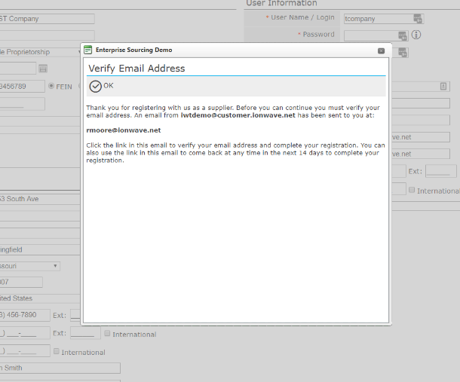
Figure 6

Addresses:
The system auto-populates the Company Address field from the information previously entered. To edit this address, click the Pencil icon located to the left of the address field. (See Figure 7.)
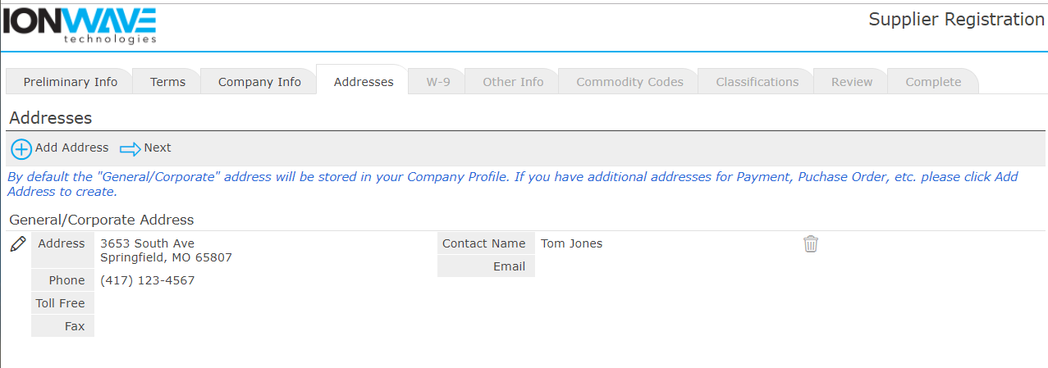
Figure 7

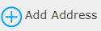
Adding Additonal Addresses:
Additional addresses can be added by clicking the tool on the gray menu bar.
Select the “Next” arrow to advance to the next tab. (See Figure 7.)

W-9:
Depending on this organization’s settings and your organization type, the system may prompt you to complete a W-9 form. You should complete this just as you would a paper version of the form. Check mark all applicable boxes, enter your name or the name of the appropriate representative, and enter the date you are completing this registration. (See Figure 8.)

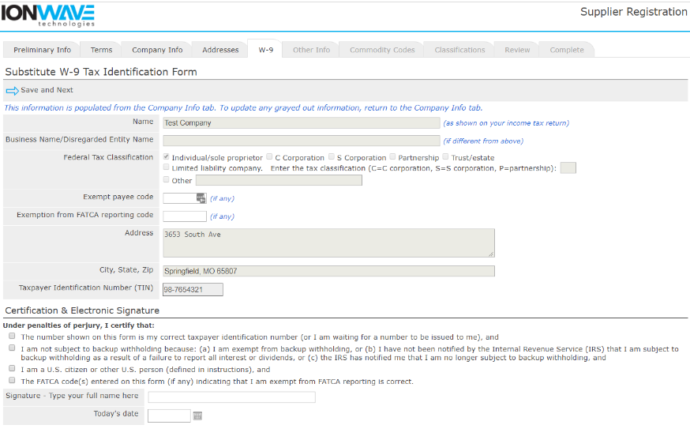
Figure 8

Other Info.:

Depending on this organization’s settings, you may be required to answer additional questions. If there are additional questions, they will be located on the “Other Info” tab. All questions with a red asterisk * are required. (See Figure 9.)
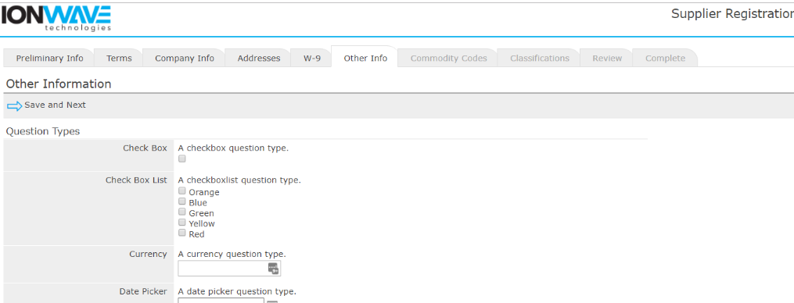
Figure 9

Commodity Codes:

Selection of Commodities will allow your organization to be invited to solicitations specifically related to business as they are released. Please review all commodities and only mark those commodities that pertain to your organization. The commodity main categories can be expanded by clicking either on the + sign or bold text. (See Figure 10.)

The Search tool allows you to enter a keyword and Search the commodity listing. The system will highlight those commodities matching your search.

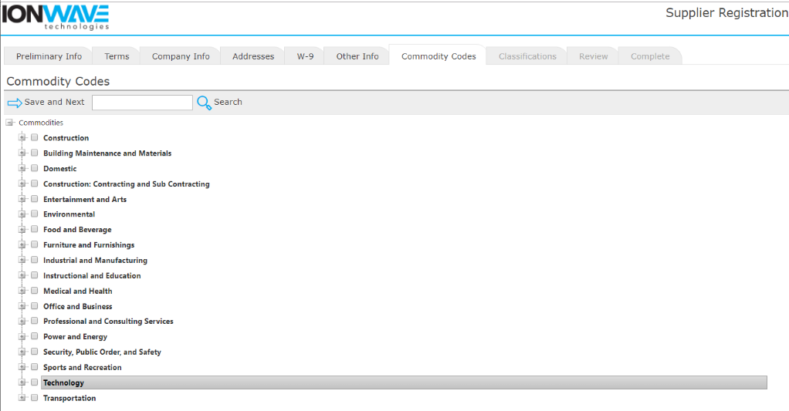
Figure 10

Classifications:

Depending on this organization’s settings, you may be asked to provide information about Special Classifications related to your business and may be prompted to upload a document verifying your qualification for this classification.

Check mark each classification that applies to your organization and if prompted, upload a document from your desktop by clicking the ‘Select’ tool and then selecting the appropriate file from your computer. (See Figure 11.)

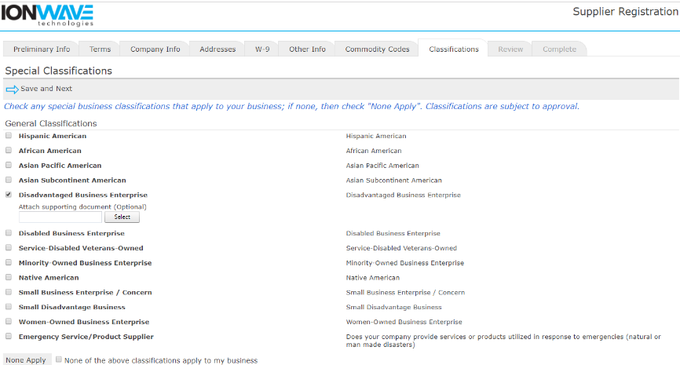
Figure 11

Review:

Look over all entered information and verify all information is correct. If you need to make corrections, you can either click the [edit] tool for that section of the tab where that information is. Click ‘Register Now’ when ready to submit. (See Figure 12.)

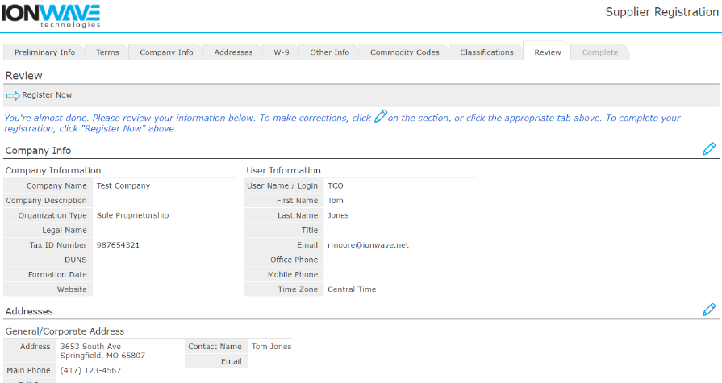
Figure 12

Complete:

Congratulations! Your registration is complete. Once your registration has been reviewed by the City, you will receive an additional email with further instructions. (See Figure 13.)

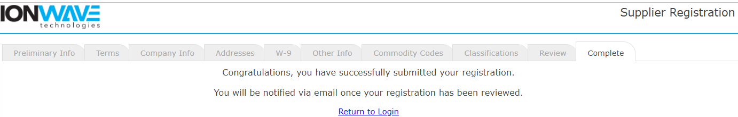
Figure 13

User Information:
Additional users can be added once your registration has been approved by the City. We highly suggest adding a secondary user. (See Figure 14.)

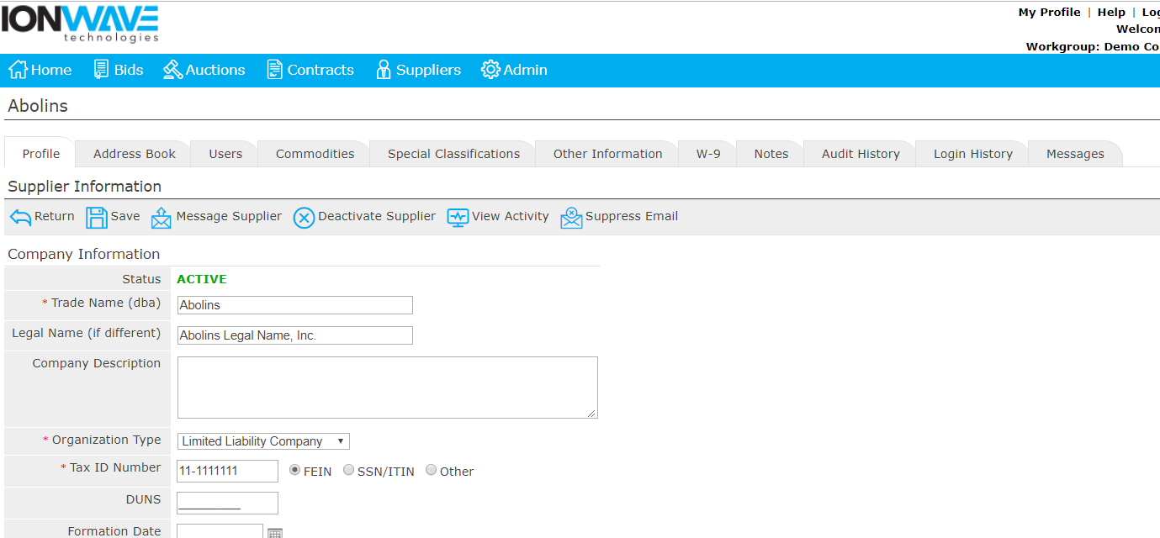
Figure 14

